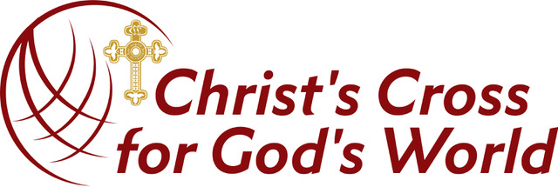

Booking Form

This Synod is being organised at three packages. Brethren are strongly encouraged to attend for the Monday and the Tuesday at least. Obligation will be met by attending on Tuesday.
For some brethren it will be appropriate to return on Tuesday evening, but they are encouraged to come to Walsingham under their own arrangements on the Thursday.

Brethren are encouraged to ask their parishes to pay the fee, and also to consider paying it for those who are retired. If financial assistance is required, please contact the Master.

In all cases, these packages are being substantially subsidised by the Society. Please note travel, transfer, meals (unless stated) and accommodation are not included in these prices.

The dinner at the Law Society is limited to 200. Please book early to guarantee a place. A waiting list will be operated if needed. Entrance to the dinner will be strictly by ticket only.

Dispensation must be sought from the Master General, no later than the 15th August 2020.

Package 1 - £125
Ideal for overseas brethren and those who want to enjoy the Synod and its fellowship.
October 12th – 15th
This will include:
October 12th Opening Synod Mass at St Alban’s Holborn followed by gala dinner and speaker at the Law Society.
October 13th Synod at Church House, including Lunch, and Evensong at Westminster Abbey.
October 14th activities available on at both S.Peter’s London Docks, including Mass and a tour of the parish or a trip to Canterbury Cathedral. Benediction and reception in the Evening.
October 15th a day pilgrimage to Walsingham (transfer provided and lunch).
Weekend partnerships with Churches can be provided to overseas brethren.

Package 2 - £100
Ideal for English and Welsh brethren who have limited time.
This will include:
October 12th Opening Synod Mass at St Alban’s Holborn followed by gala dinner and speaker at the Law Society.
October 13th Synod at Church House, including Lunch, and Evensong at Westminster Abbey.

Package 3 - £30
Ideal for retired brethren of limited means and those who have genuine other commitments.
October 13th Synod at Church House, including Lunch, and Evensong at Westminster Abbey.

Name___________________________________________________________

Province_________________________________________________________

Chapter__________________________________________________________

Address__________________________________________________________

Telephone________________________________________________________

Mobile Telephone_________________________________________________

E-mail___________________________________________________________

Please give details of any allergies:

Please provide Next of Kin details if possible:

Name___________________________________________________________

Address__________________________________________________________

Telephone________________________________________________________

Mobile Telephone_________________________________________________

Please return with cheque made payable to ‘The Society of the Holy Cross’
Card payments may be made. Contact Fr Robin Jones SSC at rdejones@me.com or +447779299924

The Synod Administrator
Mrs Mary-Claire Davies
c/o The Clergy House
62 Quakers Hall Lane
Sevenoaks
TN13 3TX
England
or by email to:

adminstrator@stjtb.com

NB: Your booking isn’t secured until full payment is received. You will then receive a Booking Confirmation.
If you don’t hear within 30 days please contact.
Fr Robin Jones SSC
rdejones@me.com
07779299924

